HOW TO CONNECT TO A WI-FI NETWORK
Windows 11 - Step-by-Step Instructions
Task: Connect a Windows 11 computer to a wireless network Estimated time: 2–5 minutes

What You Need Before You Start
- A Windows 11 laptop or desktop with a Wi-Fi adapter
- The network name (also called the SSID) of the Wi-Fi you want to join
- The Wi-Fi password, if the network is secured

Step-by-Step Instructions
Step 1 - Open the Wi-Fi Settings Panel
- Find the system tray in the bottom-right corner of your screen. This is the row of small icons near the clock.
- Click the Wi-Fi icon - it looks like a set of curved lines stacked on top of each other, similar to signal bars on a phone.
Step 2 - View Available Networks
- Inside the pop-up, click the arrow (>) next to the Wi-Fi toggle button to expand the network list.
- Scroll through the list to find your network name. Networks with more filled bars have stronger signals - choose the strongest signal you trust.
Step 3 - Connect to the Network
- Click your network name once to select it. A Connect button will appear below it.
- Check the box next to Connect automatically if you want Windows to join this network without asking each time. Skip this for public networks.
- Click the Connect button.
Step 4 - Enter the Password
- A box labeled Enter the network security key will appear. This is just Microsoft's term for the Wi-Fi password.
- Type the password exactly as provided. Passwords are case-sensitive - capital and lowercase letters are treated differently.
- Click Next to submit the password.

Step 5 - Confirm the Connection
- Wait 10–15 seconds. Windows will show "Connected, secured" below the network name if the connection was successful.
- Open a web browser (such as Edge or Chrome) and load any website to confirm internet access is working.

✅ SUCCESS
If you see "Connected, secured" in the Wi-Fi panel and websites load without issues, you are done.
Visual Aid - Connection Process Flowchart
The flowchart below maps the full connection process, including the decision point for password-protected networks.
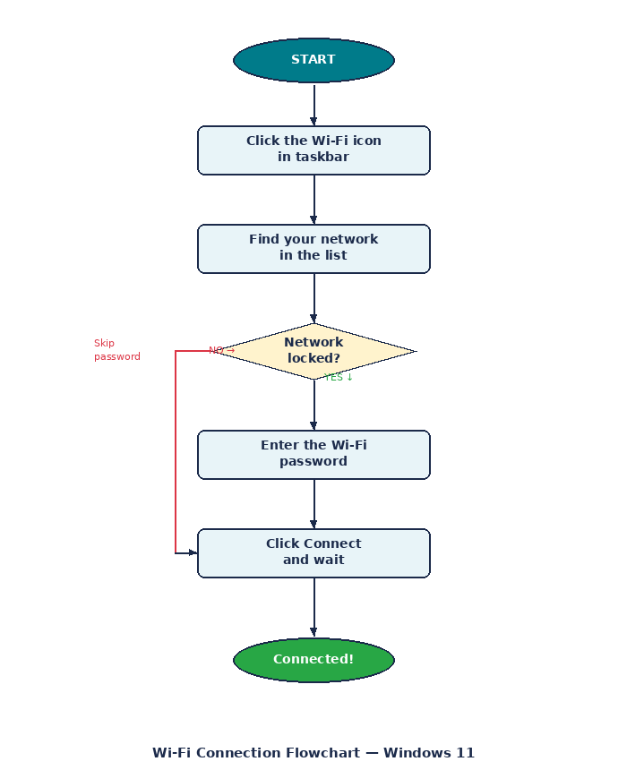

Troubleshooting Common Issues
Problem | Fix
No Wi-Fi icon visible | Press Windows key + A to open Action Center. Click the Wi-Fi button to turn it on.
Network not in the list | Move closer to the router. Restart it by unplugging for 30 seconds.
Password rejected | Re-enter carefully. Make sure Caps Lock is off and check with the network owner.
Connected but no internet | Right-click the Wi-Fi icon and select Troubleshoot problems.
Slow or dropping signal | Move closer to the router or restart your computer.

Revision Reflection
After my mother followed the original draft of these instructions without any help from me, a gap became clear and led to meaningful revisions.

What Changed and Why
The original Step 1 said only "click the Wi-Fi icon" with no indication of where to find it. My mother spent a minute searching for the wrong part of the screen. The revised version now names the right bottom corner specifically, identifies the area as the system tray, and describes the icon's appearance. Adding that context eliminated the confusion before it could happen.

How Testing Improved the Instructions
Watching someone follow the steps without any additional help was the most useful part of this assignment. Problems that seemed obvious to me as the writer were real obstacles to someone seeing the document for the first time. Technical writing assumes a level of shared context that often does not exist, and direct observation is the most reliable way to find those gaps before the document reaches its actual audience.

What This Revealed About Technical Writing
The most important lesson was that clarity is not only which words you use. It is about understanding where the user’s knowledge level is at and where they are coming from, both physically and mentally, at each step. A step that works in sequence can still fail if the reader does not know what to look for, what a term means, or what to do when something goes wrong. Effective technical writing closes those gaps before the reader has to ask.

